FACULTY EVALUATION
Programme Name: Social Entrepreneurship Development Program (SEDP)- Advance Uganda (2nd March 2026 - 6th March 2026)
Session: IT and Technology
Faculty Name: Dr. Evelyn Kahiigi
No. of Respondents: 22
No. of Participants: 22
Evaluation Parameter | (%) Individual Score | (%) Programme Average
Punctuality (Commencement and Completion of Sessions) | 78 | 91
How well do you understand the core concepts presented? | 85 | 92
Rate your confidence in applying the new skills learnt | 77 | 87
Degree of Faculty preparedness for the sessions | 87 | 97
Content and methodology of the program | 84 | 95
Quality of class and group discussions | 81 | 89
The information presented in the course is relevant to my work (ministry) | 93 | 97
Average scores | 84 | 93

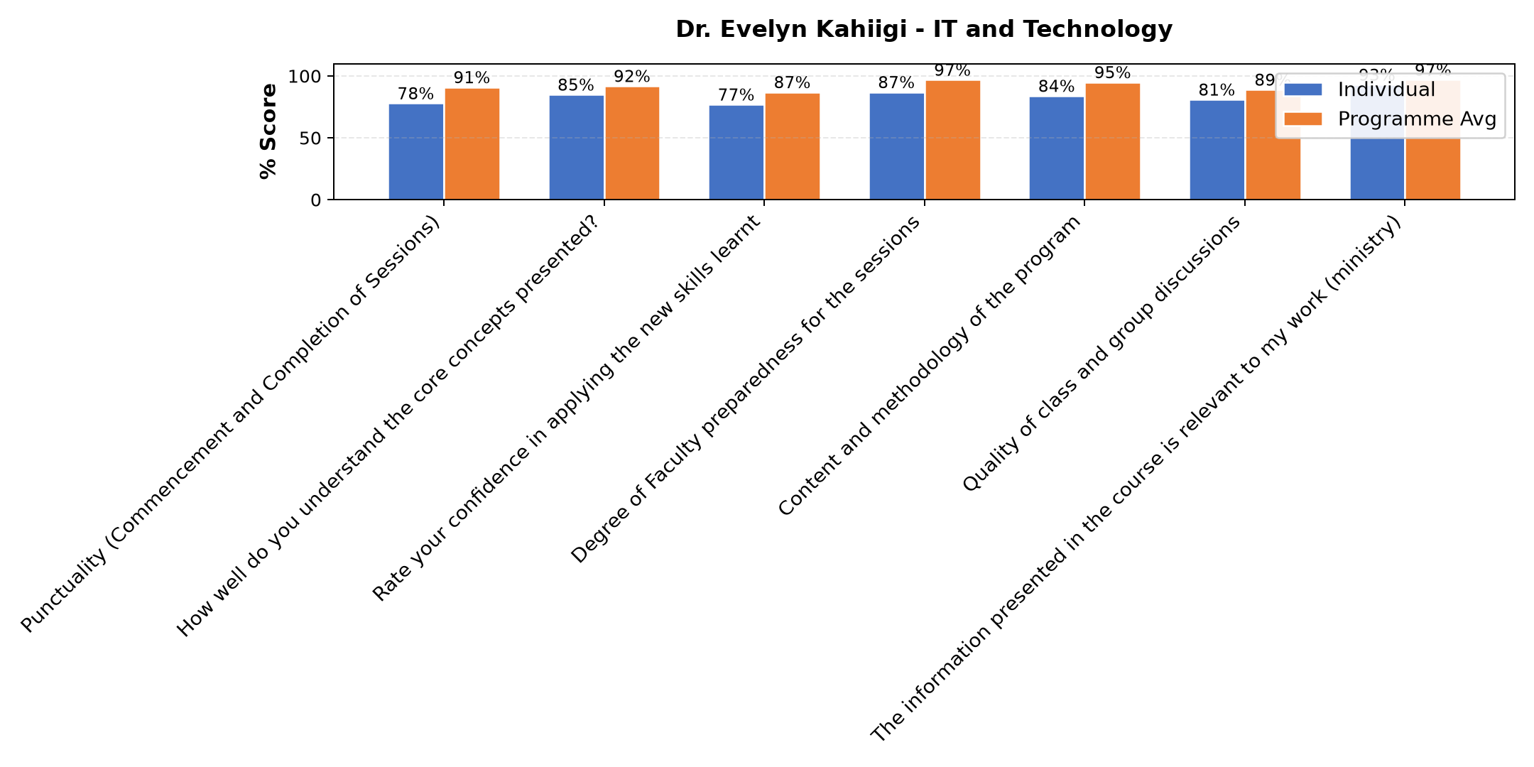

Comments & Feedback
- • Need to Learn more on IT
- • The content presented was good but not practically done.Maily theory
- • Lack of data because most of the online things needs data and it's not regularly provided in some communities like mine
- • Not being so practical I computer programs
- • The class was more of theory we needed more of practice
- • Limited know how
- • network problem, Internet data
- • Slow network
- • Lack of some tools like the computer
- • Data
- • No barriers
- • The most like barriers can be when I may run short of data since it requires data so as to connected on line. otherwise it is doable.
- • Am going to try to apply them
- • Limited support from superiors, colleagues, or management can discourage implementation. And also, time constraints—being too busy or overloaded with work—can prevent me from practicing new knowledge. Another barrier is lack of follow-up and supervision. After training, there is no guidance.
SUBMITTED THROUGH:
SBS Evaluation Automation System

